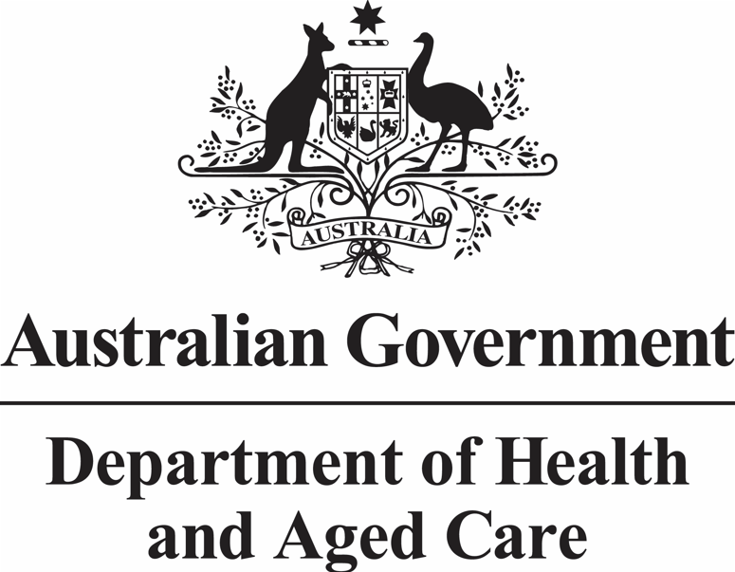

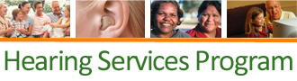

Client Application Form
Visit our website www.hearingservices.gov.au
- to find out if you are eligible
- to apply online (excludes DES and ADF)
- to find a service provider
- to find out about the services
- to find information on hearing

Further information

Under 21 years old
Access to hearing services and support for children and young adults is delivered by Hearing Australian. They can be contacted on 131 797 or by email to info@hearing.com.au

Disability Employment Services (DES) Program
If you are a participant in an Australian Government DES program, your DES Case Manager will need to apply on your behalf sending the application to hearing@health.gov.au. Please contact your case manager to discuss this further.

National Relay Service
If you are deaf or have a hearing or speech impairment, you can contact us via the National Relay Service (www.relayservice.gov.au) or call 1800 555 660.

Looking for a hearing service provider?
If you would like to arrange an appointment for hearing services, you can find a list of service providers on the program’s website. A service provider can also help you apply for the program online, which is a faster process than sending in this form (excludes NDIS and DES applications).

Website www.hearingservices.gov.au
Email hearing@health.gov.au
Phone 1800 500 726
Post Hearing Services Program
Department of Health and Aged Care
Mail Drop Point 113
GPO Box 9848
Canberra ACT 2601

Check before you send us this form
- Have you provided your
  - Full name
  - Date of birth
  - Eligibility Number
  - Postal Address
  - Email and/or phone number
- Have you read the privacy and personal information section?
- Have you signed and dated the form?
- Is the information legible?
-  DES - the application must be emailed to hearing@health.gov.au from an approved DES provider email address.
-  Australian Defence Force (ADF) - the application must be emailed to hearing@health.gov.au from your ADF email address.
Version: Effective 1 July 2022

Australian Government Hearing Services Program

Your eligibility type
* Indicates mandatory information
If you are an Australian citizen or permanent resident 21 years or older, tick the box that relates to your eligibility
*Eligibility type (please select from drop down)

Your eligibility details
*Eligibility number (CRN, DVA/PMKey or DES)

Title *Given name Middle name

*Family name

*Date of birth (DD/MM/YYYY) *Gender

Note If you are a dependent please provide the primary card holder’s details below to enable processing of the application.
Primary Cardholder’s details - applicable if you are a dependent of a cardholder
Eligibility type Eligibility number

Given name Family name

Date of birth (DD/MM/YYYY)

Your details
*Postal address

Email address

*Contact phone number

Privacy and your personal information
Your personal information is protected by law, including the Privacy Act 1988, and is being collected by the Australian Government Department of Health (the Department) for the purposes of determining eligibility for and administering the Australian Government Hearing Services Program (the program). If you do not provide this information then the Department will not be able to provide you with hearing services under the program.
You can get more information about the way in which the Department will manage your personal information, including our privacy policy, at www.hearingservices.gov.au.
By signing this form you are consenting to and authorising the Department to collect, store and disclose your information, including personal information.
*Your signature *Date

If the applicant is unable to sign, an authorised person e.g. POA or equivalent can sign on their behalf.
Relationship of signer to applicant

Correspondence preferences
Send your program correspondence to
You or Your alternate contact or Both
Alternative contact
Given name Family name

Email address

Relationship to applicant Contact number

Postal address

DES only - DES provider details
*Given name *Family name

*Email address

*Contact number

Optional Information
Are you a resident of an aged care facility? Yes
Are you of Aboriginal origin? Yes
Are you of Torres Strait Islander origin? Yes
Do you speak a language other than English at home? Yes
If yes, please list language/s spoken below
Version: Effective 1 July 2022

